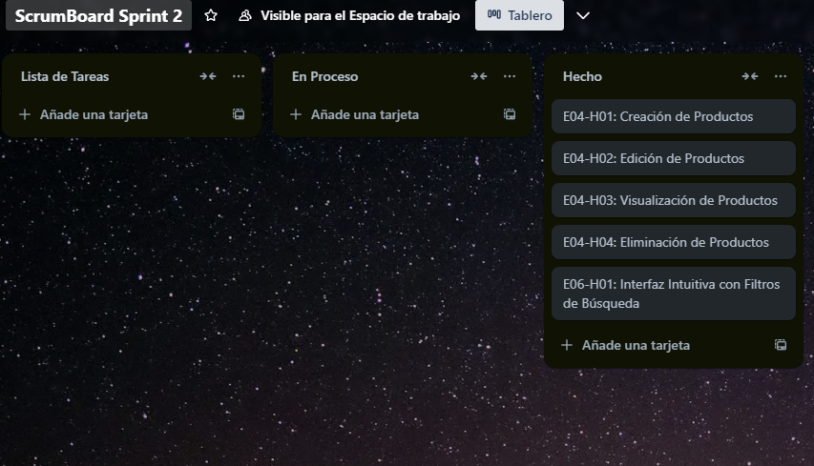  
<https://trello.com/b/nyyWHZ36/scrumboard-sprint-2>